**Question 1 : Write a program that distinguishes keywords, integers, floats, identifiers, operators and comments in any simple programming language.**

%{

#include<stdio.h>

%}

%%

[0-9]+ {printf("Integer\n");}

[0-9]+\.[0-9]+ {printf("Float\n");}

int|float|if|else|char|printf|main|switch {printf("Keyword\n");}

[+|*|/|%|-|&] {printf("Operator\n");}

"/*".*"*/" {printf("Comment\n");}

[_a-zA-Z][_a-zA-Z0-9]{0,30} {printf("Identifier\n");}

. {printf("Invalid\n");}

%%

int main()

{

printf("\n Enter the value \n");

yylex();

return 0;

}

int yywrap()

{

return 1;

}

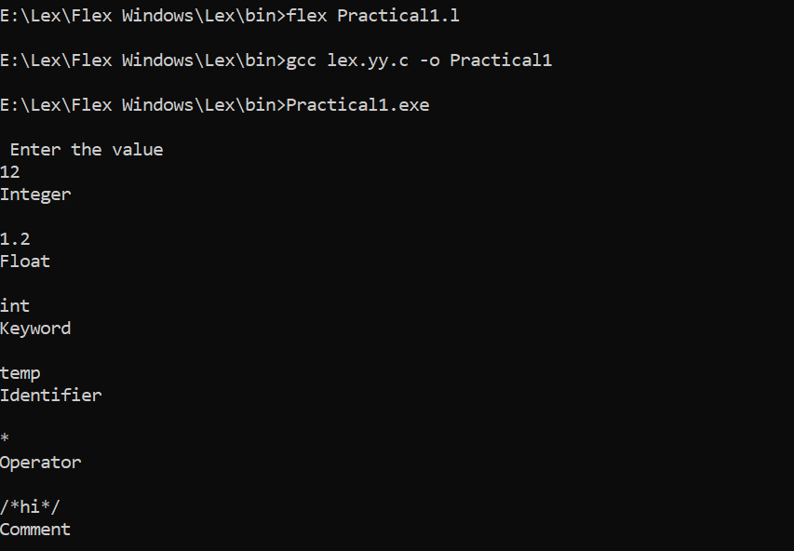

**Question 2 : A program in YACC to evaluate an expression ( simple calculator program for multiplication and division ).**

**Practical2.l file**

%{

#include<stdio.h>

#include<stdlib.h>

#include "practical2.tab.h"

int yylval;

%}

%%

[0-9]+ {yylval = atoi(yytext);

return NUM;}

[\t]+ ;

\n {return 0;}

. {return yytext[0];}

%%

**Practical2.y file**

%{

#include<stdio.h>

#include<stdlib.h>

%}

%token NUM

%left '/' '*'

%left '(' ')'

%%

expr:e{printf("Result is :: %d\n",$$);

return 0;}

e: e '*' e{$$ = $1*$3;}

|e '/' e{

if($3==0){

printf("\nDivision By Zero\n");

printf("Result is :: Undefined");

return 0;

}

else

$$ = $1/$3;}

|'(' e ')'{$$ = $2;}

|NUM {$$ = $1;}

%%

int main(){

printf("\nEnter the arithmetic expression ::");

yyparse();

printf("\nValid Expression\n");

return 0;

}

int yywrap(){

return 1;

}

int yyerror(){

printf("\nInvalid Expression\n");

exit(1);

}

